**Image Annotation Tools, and Labelling Guide**

## **Using labelImg Tool**

This labelImg tool guide is provided by Erick Chandra and modified by Andhika

**I. App Preparation**

Open-source software for labelling images: LabelImg

**Installation:**

* **Windows**: [windows_v1.8.0.zip](https://www.dropbox.com/s/kqoxr10l3rkstqd/windows_v1.8.0.zip?dl=1)​ binary installer (recommended) or build from source
* **Linux**: - PyPi installer (recommended) or build from source

- PyPi (tested on Ubuntu 14.04 and 16.04):



* **macOS**: build from source (recommended)

**For more detailed informations regarding the installation or anything regarding the apps itself, please visit this provided link:** <https://github.com/tzutalin/labelImg>

**II. Data Collection**

* As for the image that will be used for labelling, it can be in any format but it is recommended to use the most frequent image format such as **(.jpg, .jpeg, or .png)**.

-You can gather or collect the image freely from any source such as the internet or any gadgets available to you (phones, or cameras)

**III. Image Labelling**

1. Launch the labelimg app.

* For windows user, it could be as simple as type the “labelimg” in the search column. Or type “labelimg” in the command prompt.
* As for other users such as ubuntu and mac, please refer to the link provided above for instructions on how to start the app.

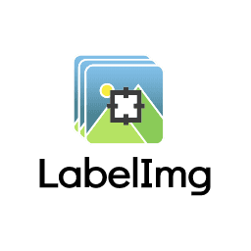

1. The image below is the user interface of labelimg. You can proceed to click the “**Open Dir**” section to open the images directory you want to be labelled on.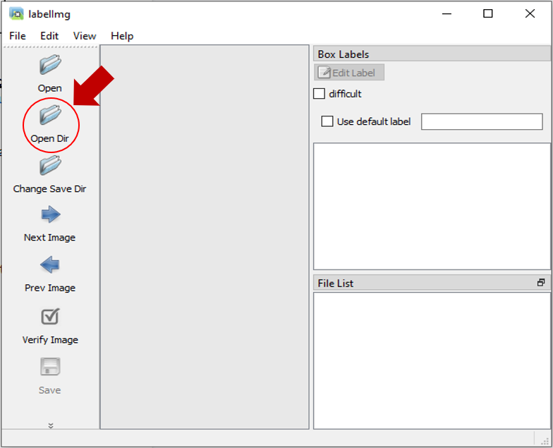
2. After you decide the directory files, the files will appear in the interface of labelimg. You can start labelling immediately by clicking the “**Create\nRectBox**”.

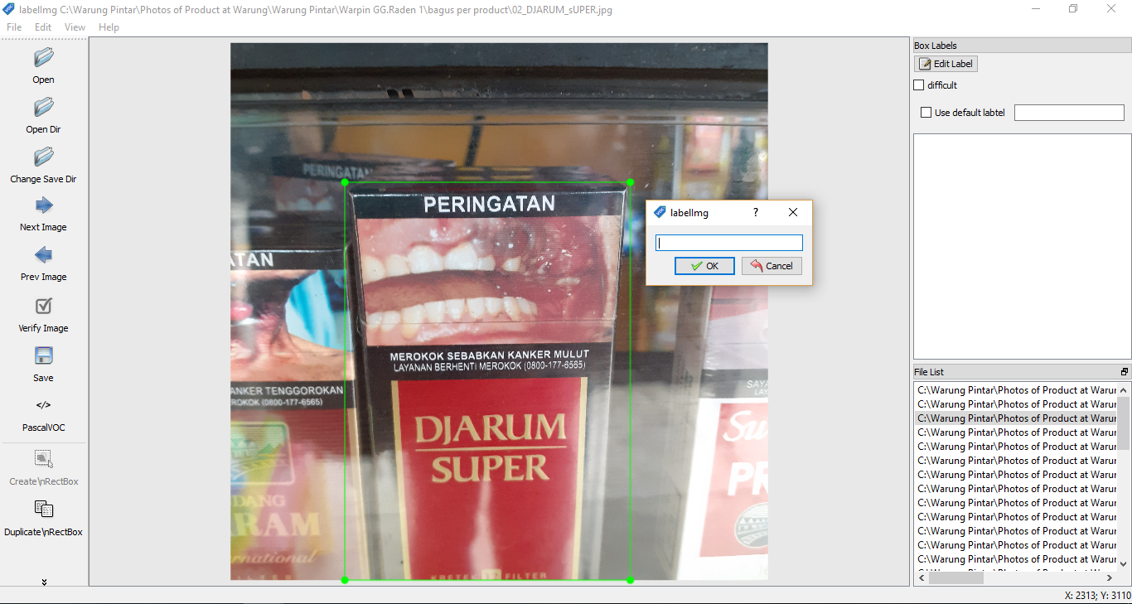

1. There will be a pop up as you can see in the image above. In that pop-up you can insert the label that you want and click ok. The label you have created will be stored in the pop-up in case you wanted to use it again for the same image.
2. It is very important to keep the consistency of the label for the same item.
3. If you have completed the image labelling, you can save the labelled image in “**PascalVOC**” format (recommended by our Brand Recognition Engineer) or in “**YOLO**” format.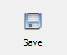
4. It is also recommended to save the files within the same folder as your keep your images to make the labelling process easier to track.

## **Using Label Studio Tool**

**I. App Preparation**

Before we go to the preparation, this app is not only for image annotation, but this tool is also used for many things such as text, audio labelling, even multi-task labelling which includes all of them.

* To install this tool:

**# Requires >=Python3.5**

**pip install label-studio**

**# Initialize the project in labeling_project path**

**label-studio init labeling_project**

**# Start the server at** [**http://localhost:8080**](http://localhost:8080)

**label-studio start labeling_project**

- For **Windows** :

1. You need the [lxml](https://www.lfd.uci.edu/~gohlke/pythonlibs/#lxml) wheel package that needs to be downloaded manually.
2. # Upgrade pip

pip install -U pip

1. # Assuming you are running Win64 with Python 3.8, install packages downloaded form Gohlke:

pip install lxml‑4.5.0‑cp38‑cp38‑win_amd64.whl

1. # Install label studio

pip install label-studio

- Formore detailed **information** regarding label-studio, you can visit these websites:

<https://github.com/heartexlabs/label-studio>

<https://labelstud.io/guide/index.html>

**II. Data Collection**

As this is not only a tool for image annotation, the data collection for this tool varies depending on what kind of labelling you want. The data collection for image annotation in this tool is the same with labelimg.

**III. Image Labelling**

1. Before you can start labelling, the first thing you need after starting the server is to choose the setup you want. You can choose the predefined configs and edit the config to have the label name as you want as in the pictures below:

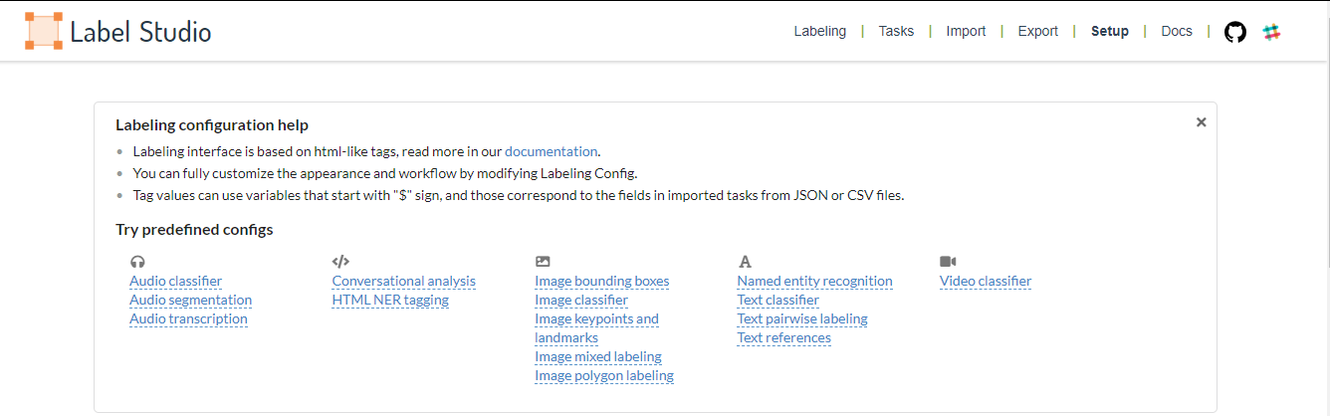

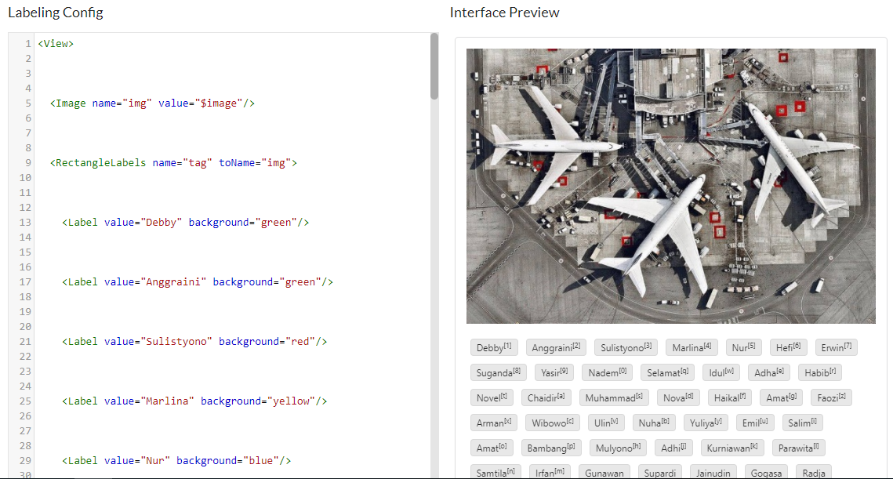

2. After you have your setup, you can now try to import the tasks (data) to the label studio. Importing the tasks (dat) is not a simple thing to do because you need to type some command line in the **command prompt.** You can see the details regarding importing tasks in the second provided link above under the “**Import tasks**” category.

3. If you have successfully imported your task, you can see how many tasks you have under the “**Tasks”** section in the user interface of Label Studio. You can see the user interface of Label Studio in the image below:

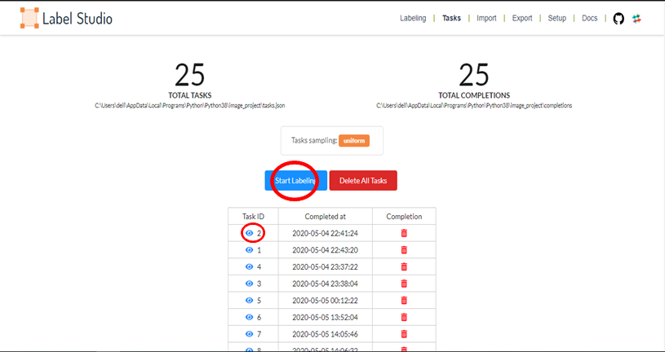

4. You can start labelling by clicking the “**Start Labelling**” button, or if you want to change the label on the image you have labelled on, you can click on the eye-like symbol.

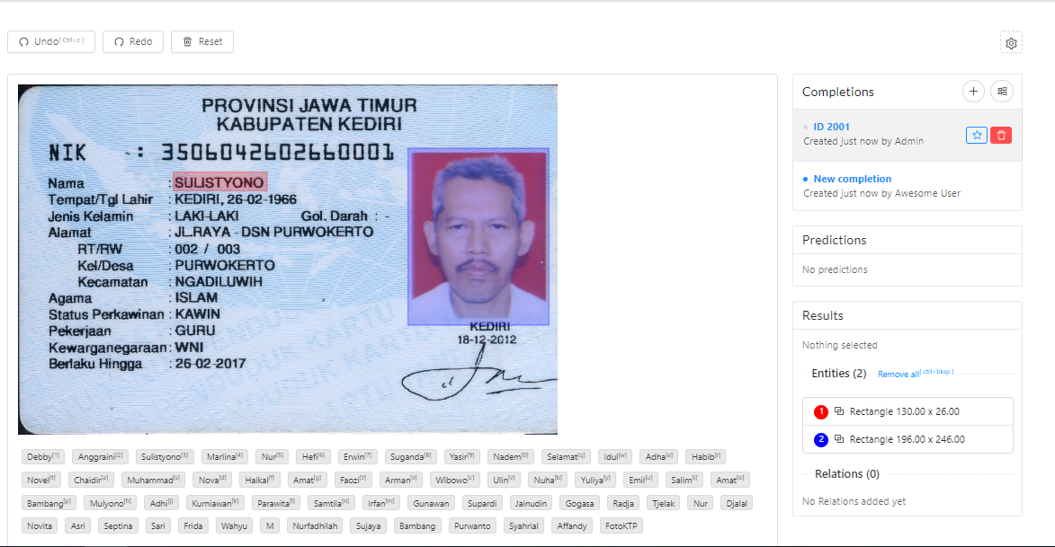

1. This is the interface of the image labelling setup in Label Studio. You can see your label either in the top or the bottom of the image. You need to click the label you want first, then you can start labelling your image. There are also some tools such as “**Undo**”, “**Redo**”, “**Reset**” to help you if you make some mistakes.

6. After you complete all your tasks, you can proceed to the “**Export**” section to finish your image labelling and download the files in the format you want.

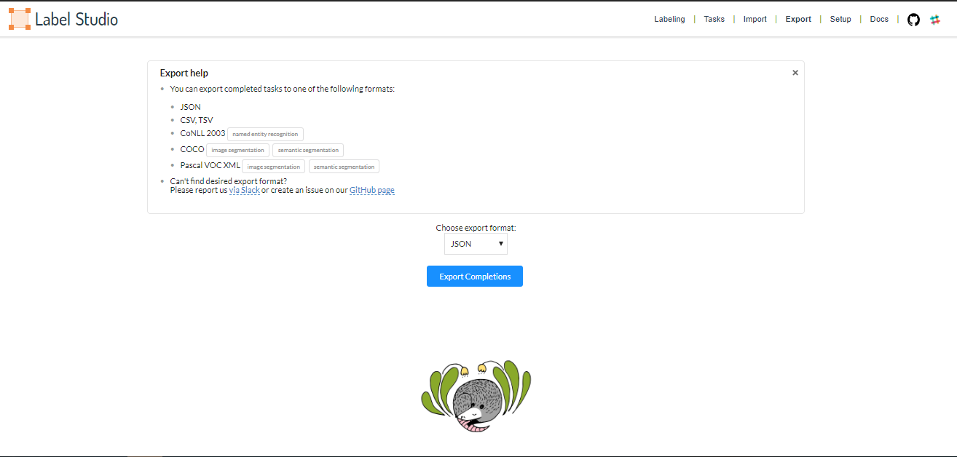

## **Using labelme Tool**

Labelme is a tool for image annotation that contains many types of labelling shape (polygon, rectangle, circle, line, and point).

**I. App Preparation**

**Installation:**

* For **Windows**:

Install [Anaconda](https://www.anaconda.com/products/individual), then in an Anaconda Prompt run:

# python3

conda create --name=labelme python=3.6

conda activate labelme

pip install labelme

* For **Ubuntu 19.10+ / Debian (sid)**

sudo apt-get install labelme

* For **macOS**

# macOS Sierra

brew install pyqt # maybe pyqt5

pip install labelme # both python2/3 should work

# or install standalone executable / app

# NOTE: this only installs the `labelme` command

brew install wkentaro/labelme/labelme

brew cask install wkentaro/labelme/labelme

For more information of **labelme**: [labelme](https://github.com/wkentaro/labelme)

**II. Data Collection**

Because this tool had some similarity with labelimg, so the data collection procedure is the same as labelimg.

* As for the image that will be used for labelling, it can be in any format but it is recommended to use the most frequent image format such as **(.jpg, .jpeg, or .png)**.

-You can gather or collect the image freely from any source such as the internet or any gadgets available to you (phones, or cameras).

**III. Image Labelling**

1. Launch the labelme tool using the command prompt.

2. Prepare the folder of the image you want to labelled on.

3. Click the “**Open Dir**” to open the folder of images that you have prepared to labelled on. You can also see the file list on the bottom right of the UI.

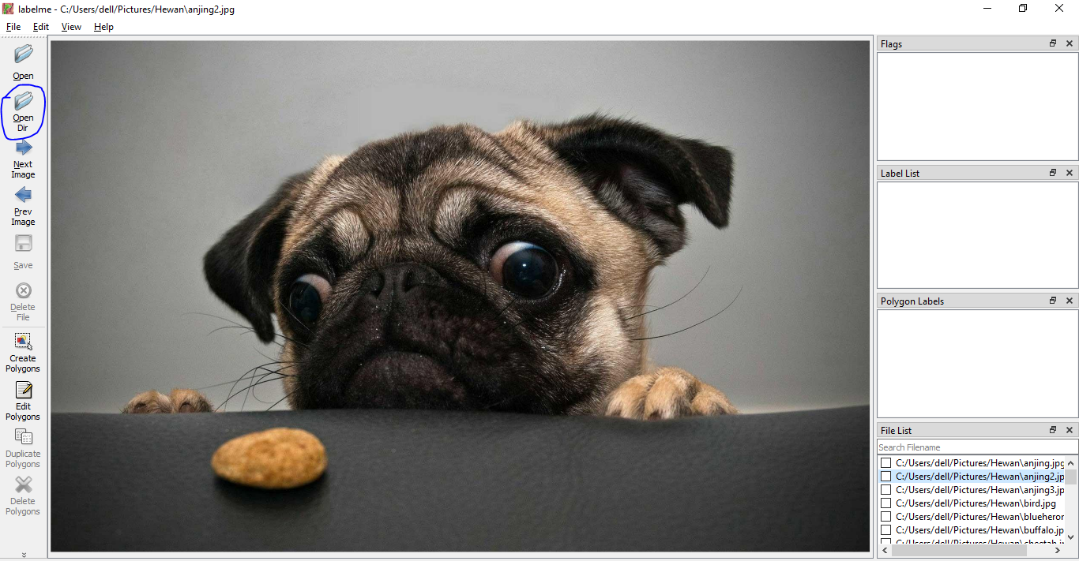

4. If you want to change the label shape, you can right click on the image, and then select the shape that you want. Here is the image: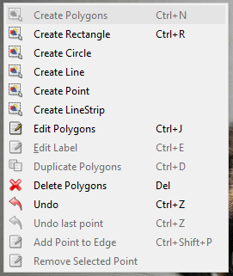

5. After you created the shape, a pop-up will be shown just like in the labelimg to put the label name you want in the labelled image. You can then proceed to save the file in the save section under the “**Prev Image**”. In the “**File List**” on the bottom right, you can see the check mark on your finished labelled file, so you can keep track of your work easily.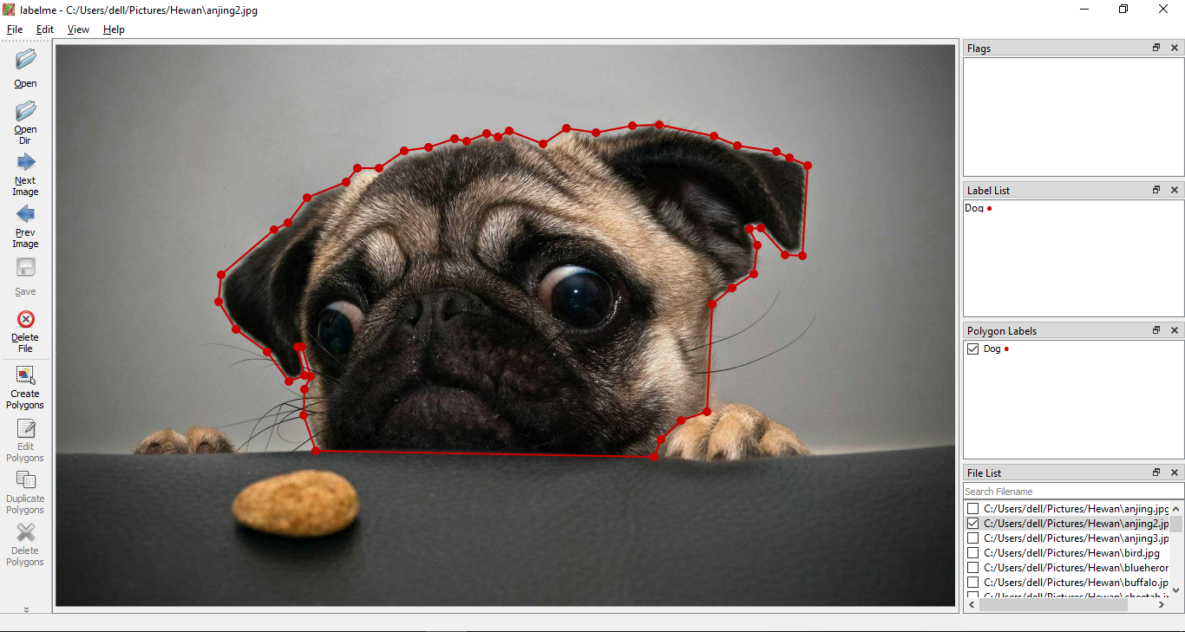

## **IMPORTANT NOTE!**

* Because labelimg only has one shape which is the rectangle shape, it is okay to stretch out a little bit from the actual image that you want to labelled on, if the case is similar to the example provided in the labelimg section.
* It is okay to have a little intersection between the shape of the image if there are more than one shape in the image.
* For best results, it is very recommended to create the shape that is very accurate to the image.
* If the tool you use provides more than one shape, use whatever shapes that are best to produce maximum results so long it is accurate to the image that you labelled on.